Relief Valve Hardware Specification
PB 540

1. INTRODUCTION 3
1.1 Purpose 3
1.2 Scope 3
1.3 Revision History 3
2. Operation 3
3. Design Requirements 3
3.1 Leakage Criterion 3
3.2 Cracking pressure 3
3.3 Relief pressure 3
3.4 Gas Compatibility 3
3.5 Operating Temperature 3
3.6 Ambient Humidity 3
3.7 Operating Positions 4
3.8 Size 4
3.9 Weight 4
3.10 Life 4
3.11 Labelling / Traceability 5
3.12 Mounting 6
3.13 Packaging 6

INTRODUCTION

Purpose
This document provides the specification for the low pressure relief valve for the PB640, PB560, PB540 and PB520.

Scope
This specification describes the functional requirements for the low pressure relief valve for the PB640, PB560, PB540 and PB520.

Revision History
Revision | Date | Author | Change Description
A | 02 Jun 08 | J.C. Cabrera | Initial Release of Specification
B | 03-Nov-2008 | G. Sanchez | Made minor formatting changes

Operation
The relief valve is used to avoid high patient pressure – when the pressure is higher than ~80mbar, the valve opens up and the pressure is vented out of the device. It is used on the homecare ventilators for continuous or temporary use
This component is mainly used as an autonomous and backup security function since the ventilator is already equipped with a numerical system based on two pressure sensors.

Design Requirements

Leakage Criterion
HWPRV1 The pressure relief valve shall leak less than 0.1 l/min at pressures less than or equal to 60cmH₂O.

Cracking pressure
HWPRV2 The pressure relief valve shall flow > 0.5 l/min between 60 cmH₂O and 70 cmH₂O (Cracking Pressure).

Relief pressure
HWPRV3 The pressure relief valve shall limit pressure below 100 cmH₂O with a flow source up to 80 l/min.

Gas Compatibility
HWPRV4 The pressure relief valve shall be compatible with Air and Oxygen mixtures from 21% O2 to 100% O2.

Operating Temperature
HWPRV5 The pressure relief valve shall operate within specification with device temperatures between the device ambient temp 0 to 50°C.

Ambient Humidity
The pressure relief valve shall operate within specification in humidity levels from 5 to 95% RH.

Operating Positions
HWPRV6 The pressure relief valve shall work in all 6 axes.

Size
HWPRV7 The pressure relief valve shall have the following dimensions: Length 23.0mm ± 0.5 - Diameter 18mm ± 0.2

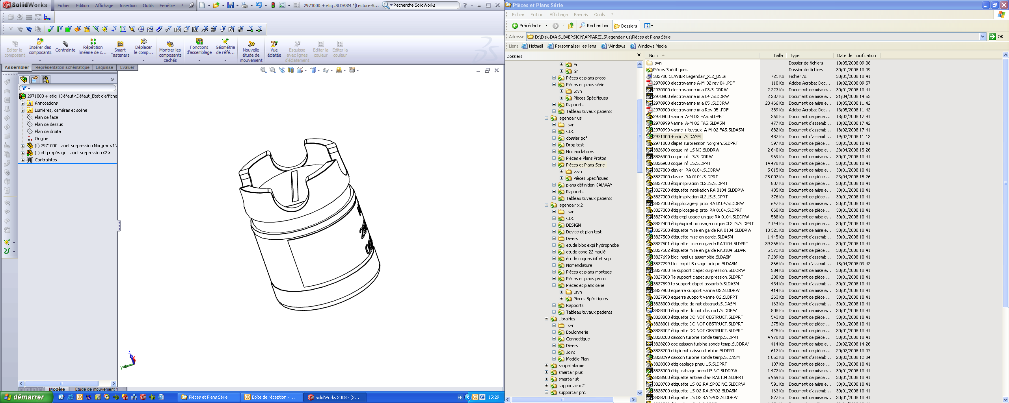

Weight
HWPRV8 The pressure relief valve shall weigh less than 10g.

Life
HWPRV9 The pressure relief valve shall have an operational life of greater than 1000 cycles.

Labelling / Traceability
HWPRV10 The pressure relief valve shall be labelled with the following information:
The manufacturer name: NNNNNNNNNNNNNNN
The agile part number: AIROX-2971000
The Manufacturer Part Number: PPPPPPPPPPPP
The Revision: REV: X
Reserved Manufacturer Spec Number: RR-RRR-RRR
The week (WW) / year (YY) / lot quantity (QQQ)
The serial number: AXNNNNNN

NNNNNNNNNNNNNNN
AIROX-2971000PPPPPPPPPPPP
REV : XRR-RRR-RRRWW/YY/QQQ
AXNNNNNN

Mounting
HWPRV11 The relief valve is mounted in the Silicon Tee tube output – The valve shall be pushed in the Silicon Tee output until the Valve neck.

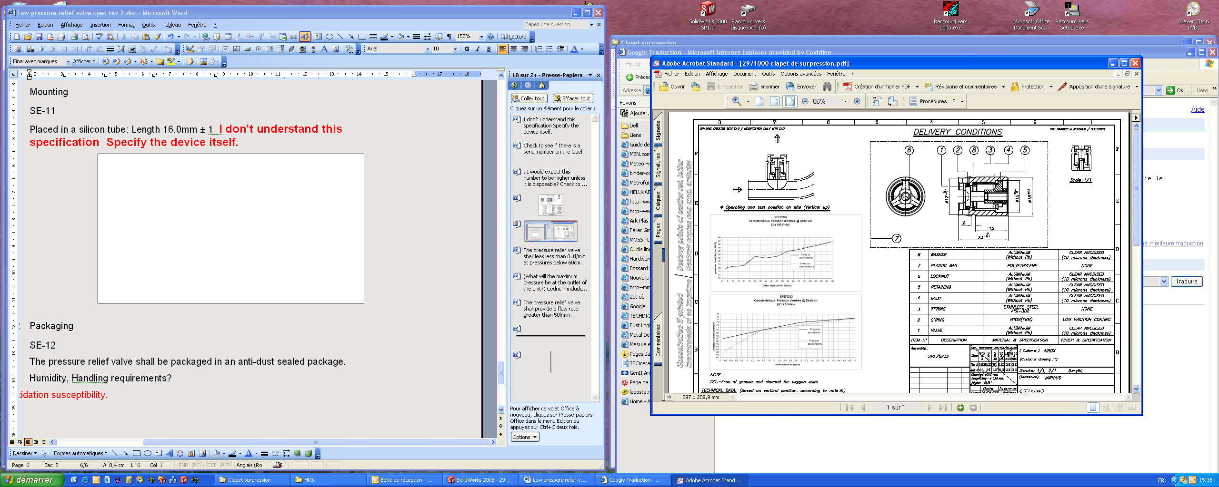
Silicon Tee
Output
Input
Valve Neck

Packaging
HWPRV12 Packaging shall be tested to the international standard ISTA2A.
HWPRV13 The pressure relief valve shall be clear anodised.
Certificate Of Compliance is required.

